JIRA Administrator
Create Story , Epic and Sprint

- New Agile Project
- Create Project options we can go and create our worn project and also we can make is a agile project and once done you can see below screen.
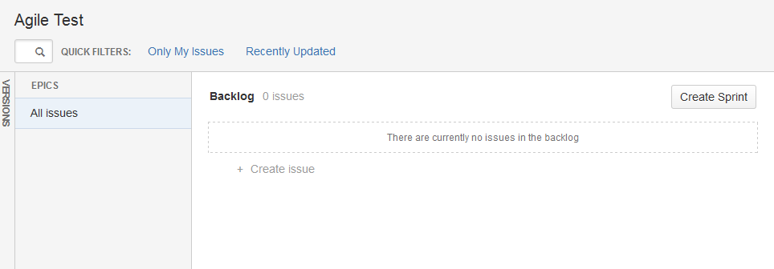

First we need to create a user story like below
- Click create button in the top and you will see below option
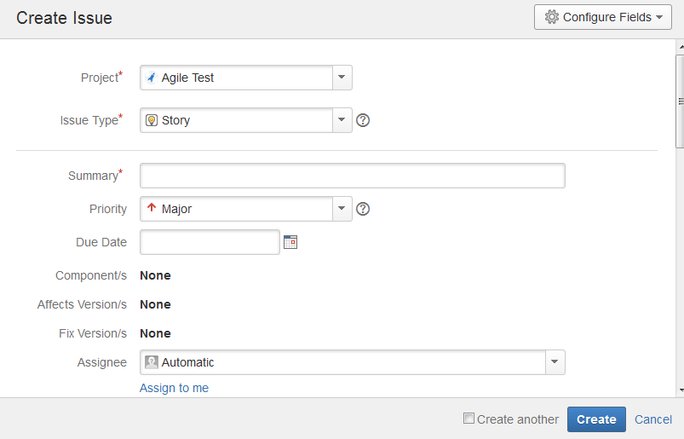

Once story is created you will see screen like below
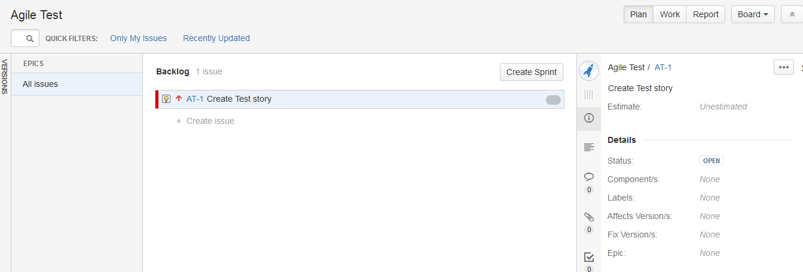

Go to epic and click epic like shown in the below screen
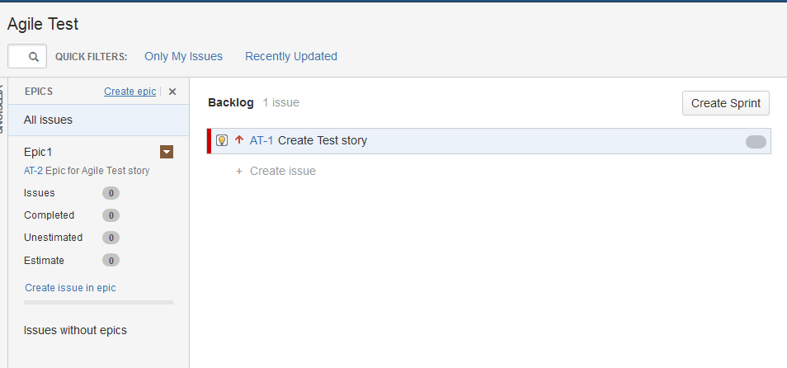

Then need to point jira story created to the epic , by drack story and put in Epic12

So once done you can see JIRA story is assosicated with the epic1 like below

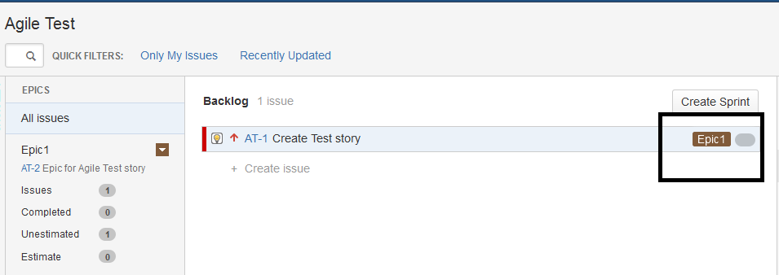

Now we need to create sprint for the project story and epic created

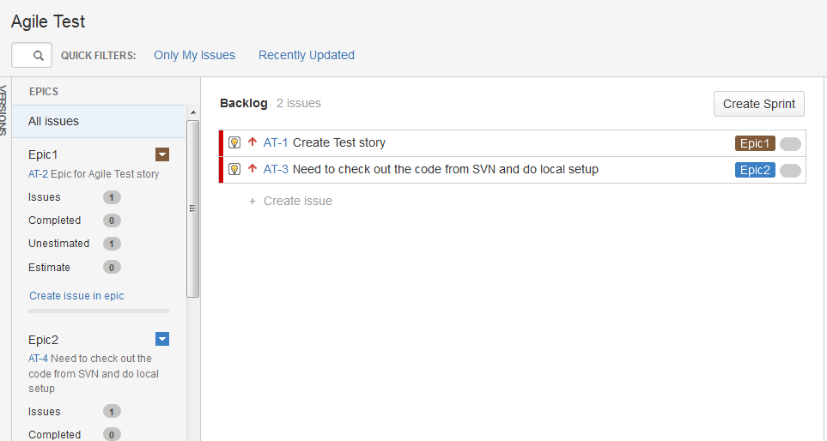

So from this you can see all the JIRA story created are in Backlog 2 issues, so you need to create a sprint in it, so click create sprint and drack those issue to those corresponding srrint like below

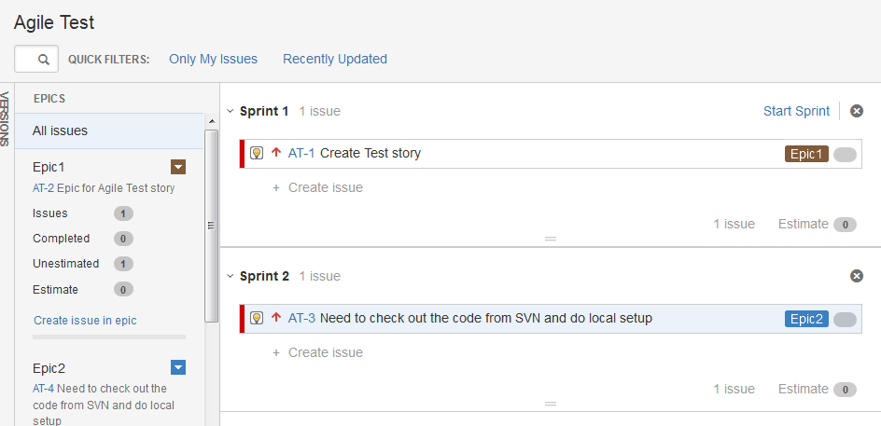

So once started the sprint, you need to mention the time span to complete the task and you will see the screen below once those sprint is created.

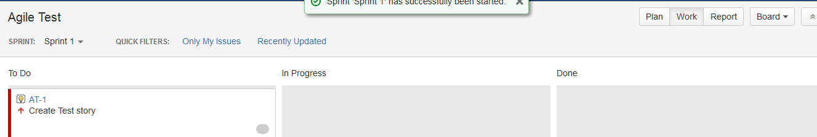

So once the sprint is started we

